**COSC422 Assignment 3 Report**

**The Scene**

(Narrator) The life of a museum guard is an easy life. (Museum guard) “All I do is walk around some priceless science based objects all day, making sure nothing bad happens”, Figure 8. (Narrator) He soon finds out that his job could be in jeopardy when something unexpected happens by the cannon one fateful day. His boss is so happy, that he doesn’t even notice the commotion behind himself, Figure 2,3,11.

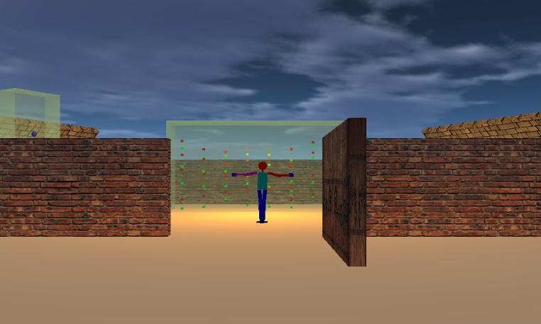

Figure 2 – Door opened – The Boss is Dancing

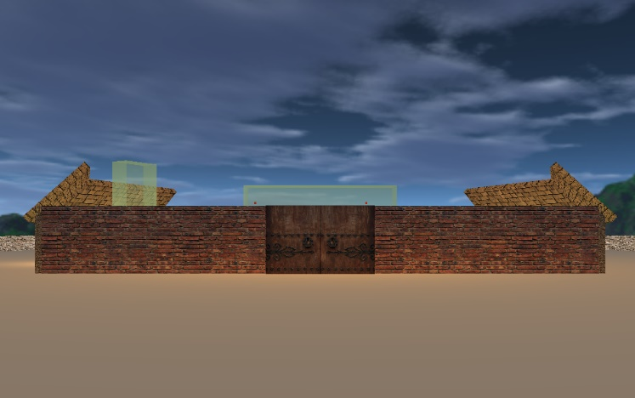

Figure 1 - Museum Environment

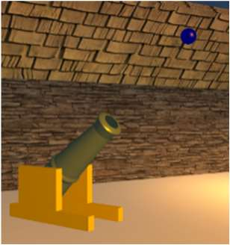

Figure 5 – Cannon firing

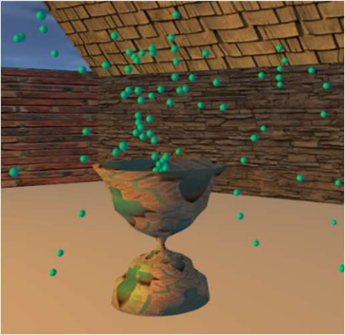

Figure 4 – Particle System

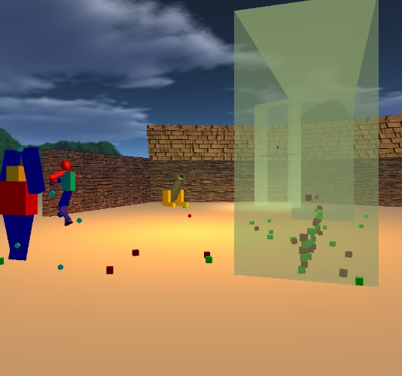

Figure 3 – Cannon Fired – cubes scattered

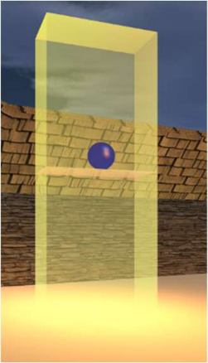

Figure 7 – Magic ball

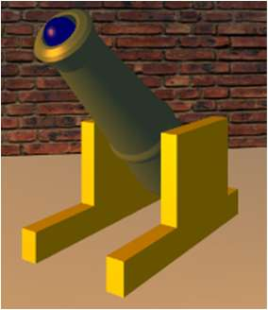

Figure 6 – Cannon Reset

Figure 9 – Magic cubes

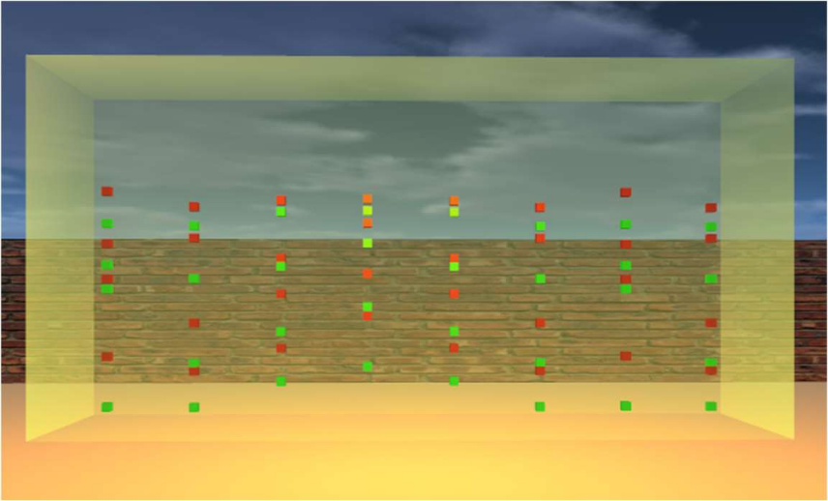

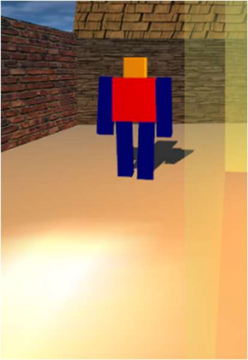

Figure 8 – Cannon Reset

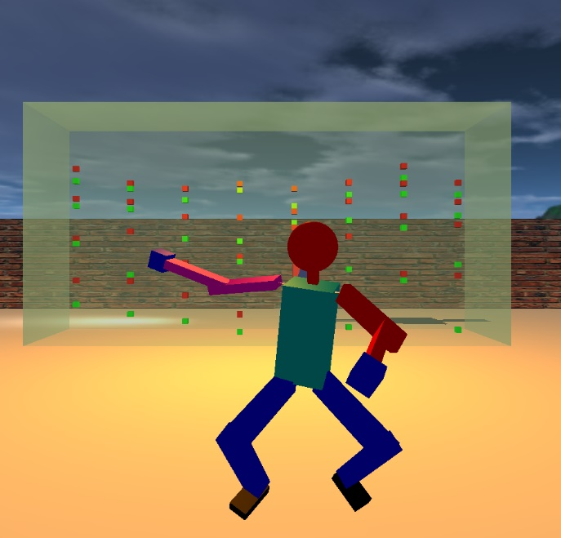

Figure 11 – GLUT objects model animation

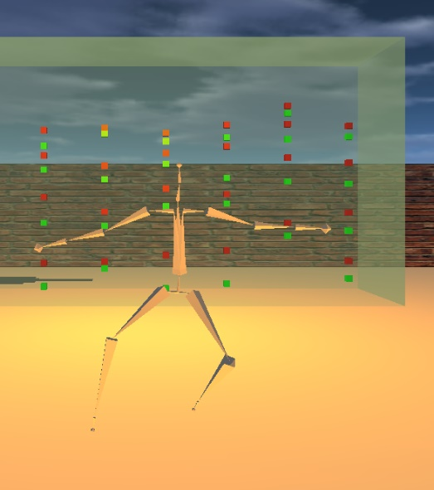

Figure 10 – Skeleton model animation

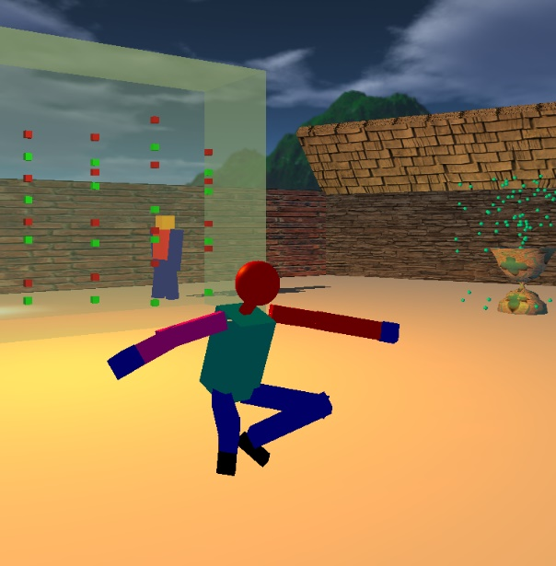

Figure 13 – Happy Boss

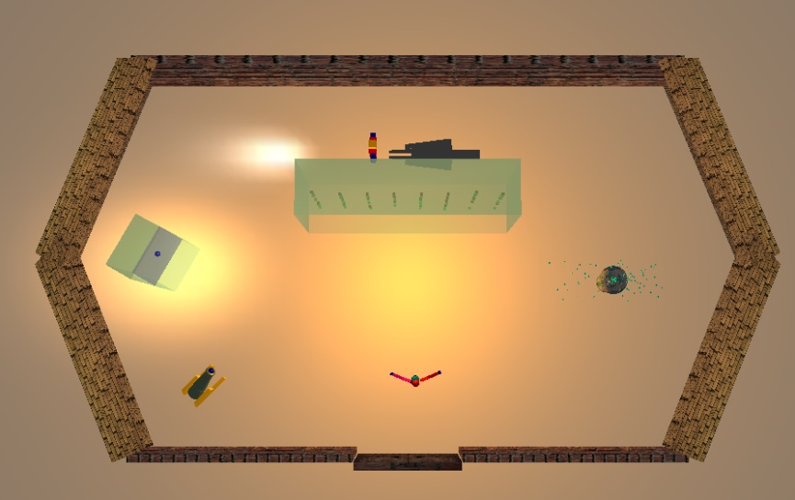

Figure 12 – Top Down View

# Model Enhancement

Enhancing the model between a skeleton model to a GLUT object model required modifying the *render()* in *display.cpp*. By pressing ‘E/e’, this toggle between the two different renders, seen in Figures 10 and 11. Figure 13 shows that there is a detailed *Boss* object, and a basic employee. This employee also has a planar shadow being shown on the floor.

To be able to use GLUT objects on the skeleton model animation (Figure 10), a 3rd party open source animation loader *Assimp* was used. This allows us to load *.bvh* animation formatted files to be able to link animations to a object. Diffuse + Ambient Shadow reflections can also be seen as the *Boss* dances.

# Character’s Environment

The environment shown in the Figures above were made from GLUT objects. For this part of the assessment, the GLUT objects scene was modified from the first COSC363 assessment. Figures 1 to 8 show images of these.

Environment features:

* Skybox – scene background
* Door – Toggle ‘D/d’ to open and close
* Museum – House of fun
* Custom fountain -- Particle System – randomly directed particles
* Magic ball – changes sizes
* Magic cubes – inside a *gravitational less* cabinet

For the physics based environment motion. Multi-Threading was implemented to help increase efficiency for the environment. Currently implemented to use 2 cores in a Linux environment.

# Extra features

There was quite a lot of extra features, especially physics related. Overview of features:

* Planar shadows
  + Seen in Figure 12, the basic GLUT model shows having a planar shadow
* Camera, motion & view (toggle ‘V/v’)
  + Moving around the scene – first person camera, controlled by the 4 arrow keys.
  + Top down view – zoom in ‘+’, zoom out ‘-‘, plus with all 4arrow keys. Figure 12 shows this.
* Animation looping
  + The period is reset when animation finished
* Environment Physics
  + Collision detection, Magic ball, and magic cubes
* Enhancement mode
  + Toggle ‘E/e’ to see difference between models.

# Control Functions

|  |  |
| --- | --- |
| ↑  Move forwards | ‘+’  Zoom in – top down view |
| ↓  Rotate backwards | ‘-‘  Zoom out – top down view |
| ←  Rotate left | E/e  Toggle *manager* model enhancement |
| →  Rotate right | ‘q’ or 'ESC'  Exit application |
| Spacebar  Fires the cannon |  |
| D/d  Toggle door |  |
| V/v  Toggle view (top down or first person) |  |

**Compiling & Running Application**

On a Linux Machine, on the Makefile level, type:

‘make && make program’

**References to Sources**

* Model animations were from the lab.
* Environment Textures - <https://www.textures.com/>